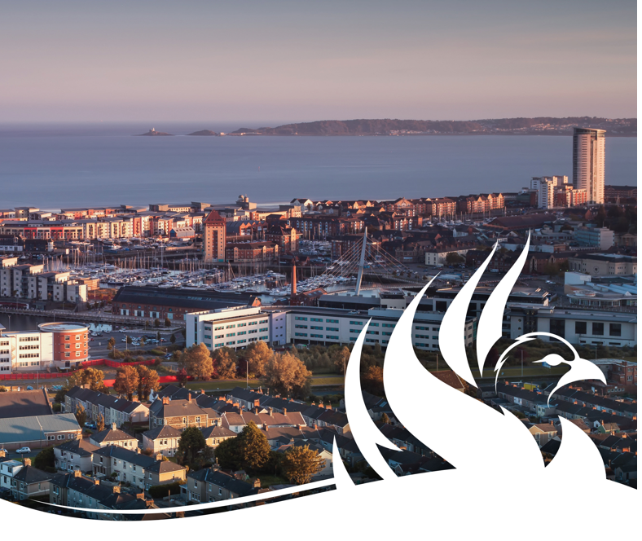
Relationships and Sexuality Education (RSE) Policy

Knelston Primary School

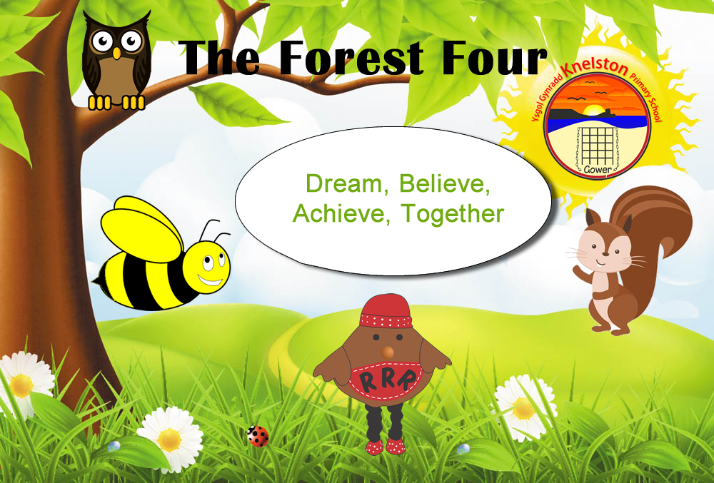
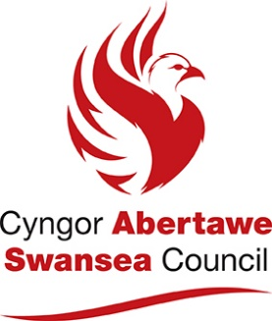

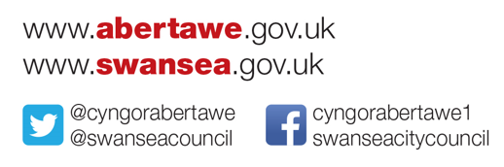
Date of implementation | October 2025
Date of policy review | October 2026
Name of RSE Lead | Kate Porter AOLE Lead  Health and Well-being

Contents

 | Page
Introduction | 4
Aims and objectives of RSE | 4
Equal opportunities | 5
Teaching and learning | 5
Safeguarding and child protection | 5
Co constructing with pupils | 5
Working with parents/carers | 5
Working with visitors and external agencies | 5
Developmentally appropriate RSE | 5
Monitoring RSE | 6
Appendices | 6
Curriculum map (code) | 6
Further policies | 6
Resources and Services to Support RSE | 7

Introduction

RSE is a positive and protective part of the Curriculum for Wales. It plays a central role in supporting learners’ rights to enjoy fulfilling, healthy and safe relationships throughout their lives.

Central to the Curriculum for Wales is an aspiration for every child and young person to achieve the four purposes of the curriculum. A rights and equity based RSE curriculum helps ensure that all learners can develop an understanding of how people’s faith, beliefs, human rights and cultures are related to all aspects of RSE and how these rights can contribute to the freedom, dignity, well-being and safety of all people. Therefore, within Knelston Primary School, we will discuss RSE in the context of the Rights protected by the United Nations Convention on the Rights of the Child.

RSE at Knelston Primary School will support learners to develop the knowledge, skills and values to understand how relationships and sexuality shape their lives as well as the lives of others. Learners will be equipped and empowered to seek support on issues relating to RSE and to advocate for self and others.

RSE is a mandatory requirement in the Curriculum for Wales for all learners from age 3 to 16 (“the Act”). This means that all learners must receive this education. There is no right to withdraw from RSE within the Curriculum for Wales.

This policy has been written in accordance with the Curriculum and Assessment (2021) Act; link here.

The RSE policy has been written to link with other school policies and processes at Knelston Primary School, These include:

- Safeguarding and child protection
- Behaviour policy and procedures
- Anti bullying policy and procedures
- Online safety policy
- Equalities Policy
- Learning and Teaching policy

Aims and objectives of RSE

The aim of RSE at Knelston Primary School is to give young people the information they need to help them develop healthy, nurturing relationships of all kinds, not just intimate relationships. It should enable them to know what a healthy relationship looks like and what makes a good friend, a good colleague and a successful marriage or other type of committed relationship. It should also cover contraception, developing intimate relationships and resisting pressure to have sex (and not applying pressure). It should teach what acceptable and unacceptable behaviour in relationships is.

In accordance with legislation, RSE at Knelston Primary School will be inclusive, pluralistic, factually correct and provide opportunities for learners to critically engage and respond to all areas of the RSE curriculum. Staff will be well trained and all resources used will be carefully selected in line with the needs of the learners.

RSE will be taught through the Health and Wellbeing area of learning/ through cross cutting themes/ via discreet RSE lessons.

Equal opportunities

Refer to Knelston Primary School’s strategic equal opportunities policy.

Teaching and learning

Refer to Knelston Primary School’s teaching and learning policy.

Safeguarding and child protection

Refer to Knelston Primary School’s safeguarding and child protection policy.

Co constructing with pupils

In accordance with the United Nations Convention for the Rights of the Child, learner voice will be used to support in constructing the RSE curriculum at Knelston Primary School and learners will regularly have opportunities to evaluate and review our RSE provision to ensure that it effectively meets their needs.

Working with parents/carers

All parents/ carers will be kept informed about the provision of RSE at Knelston Primary School and will be encouraged to see RSE as a shared responsibility between school and home.

Working with visitors and external agencies

When visitors and external agencies provide sessional learning opportunities for learners, the school will ensure that:

- The school and the external provider have agreed the aims, content and approach to be adopted.
- The local authority (education department) know of and have approved the agency as a provider of RSE support within schools.
- The school has made the provider aware of any relevant school policies.
- The school has informed and prepared pupils ahead of the visit and allowed them time to prepare questions.
- Schools who commission external agencies will apply and follow the safe recruitment and commissioning procedures of the local authority.
- The school has planned for the provider to be actively supported by a teacher throughout the visit.

Developmentally appropriate RSE

The Act requires that the RSE provided must be developmentally appropriate for learners. Therefore, schools and settings must take account of a range of factors such as the learners age, knowledge and maturity and any additional learning needs. RSE at Knelston Primary School will be developmentally appropriate for each learner. The age of learners should be one of the criteria by which practitioners decide upon the appropriateness of content; however, there will be other factors they will need to consider when planning provision. Factors such as the physical and mental and emotional development of learners should also be taken into account. This is essential to ensuring learners are kept safe from information for which they are not sufficiently mature to process. This, however, should not be a reason for not providing children and young people with the essential information they need as they develop physically, mentally and emotionally; developmentally appropriate RSE requires the coverage of subjects that are integral to learners’ development. For example, issues which may affect some younger learners, such as puberty and menstruation, should be engaged with sensitively and before the onset of physiological changes. We will also consider how appropriate support is provided through a whole school approach such as, in the case of puberty, ensuring that learners have access to sanitary products.

Monitoring RSE

Although RSE is a whole school responsibility, RSE will be monitored, reviewed and evaluated by those with responsibility for RSE at Knelston Primary School in line with the school’s curriculum policy. This includes:

- The representative from the Governing body with responsibility for RSE
- The Headteacher and Senior Leadership Team
- The RSE lead
- Learners

This RSE policy will be reviewed every year and this process will include all of the above, alongside other members of our school community (parents/ carers, the Governing body and learners) to ensure that our RSE provision and curriculum is effective in meeting statutory requirements.

Appendix

- Curriculum map (code)

The code can be found here. The three strands are:

- Relationships and identity
- Sexual health and wellbeing
- Empowerment, safety and respect

Our curriculum plan takes account of the three phases of learning, as well as the developmentally appropriate needs of our pupils and is available to share on request.

The three phases of learning are:

- Phase 1 – from age 3
- Phase 2 – from age 7
- Phase 3 – from age 11

- Further policies

- Behaviour policy and procedures
- Safeguarding and child protection policy
- Anti-bullying policy and procedures
- Mental health and wellbeing policy
- Online safety policy
- Equalities policy
- Resources and Services to Support RSE

- Swansea Bay School Health Nurse Service - SBU.SchoolNursing@wales.nhs.uk
- Cross-cutting themes for designing your curriculum – Welsh Government RSE Code and Guidance.
- Brook Learn - A range of high-quality, self-directed and mostly free-to-access courses to empower, support and encourage you to deliver effective relationships and sexuality education.
- Spectrum - Educating schools, pupils and parents in Wales about healthy relationships by taking a whole school approach to tackling domestic abuse.
- Growing Up/Tyfu I Fyny Resource – Supports delivery of RSE. Only available via HWB.
- SENSE Interactive Resource – Supports delivery of RSE. All schools have been provided with a copy.
- SchoolBeat - Providing information and resources for pupils, teachers, parents and partners to reinforce the key messages delivered by our School Community Police Officers in primary and secondary schools as well as alternative educational settings.
- Frisky Wales – NHS Wales Sexual Health Website.
- NSPCC Learning - Training and resources to help you protect children from neglect and abuse.
- PANTS Resource - Free resources for schools and teachers including a lesson plan, slide presentation, curriculum links, classroom activities and more.
- Underwear Rule - A simple conversation to help parents keep their child safe from sexual abuse.
- Stonewall Cymru - Supporting schools to become more LGBTQ+ inclusive.
- ThinkuKnow Toolkit - Information and guidance which is appropriate and relevant to the experiences of young people aged 11-18. The toolkit includes activities that can be delivered as one-off lessons or used as part of young people’s relationships and sex education.
- Kooth - Kooth is a free, safe and anonymous online wellbeing service for children and young people.
- Meic – A free 24-hour helpline for children and young people in Wales. MEIC provides advice and support for a range of issues including bullying and sitting exams.
- Agenda - A downloadable resource for educational practitioners who want to support children and young people (aged 7 – 18) to make positive relationships matter in their school and community.
- Crush - CRUSH is a free downloadable resource designed to prepare teachers for the new RSE Code and Guidance.
- Terrence Higgins Trust – Information about HIV, other sexually transmitted infections and how to maintain good sexual health.
- CAFOD - Education resources for primary and secondary schools.
- Amnesty International UK – Ordinary people from across the world standing up for humanity and human rights.
- Mentally Healthy Schools - Learn without fear: girls' rights school pack.
- Kaleidoscope Trust – Freedom, safety and equality for LGBT+ people.
- Barnardo’s - Resources to help identify and engage young people at risk of sexual abuse and exploitation.
- Let's Talk About It - Relationships & Sex Education Support.
- Repository - Hwb (gov.wales)
- Children’s Commissioner for Wales – Resources for schools.
- Education and Training Foundation - Useful resources – Prevent for Further Education and Training.
- Swansea Bay RSE Teaching Pack – Lessons from Reception to Year 6, includes School Nurse lessons on hand washing (Reception) and puberty (Year 5). Only available via HWB.

