Knelston Primary School
Learning and Teaching Policy

At Knelston Primary School we recognise and celebrate the uniqueness of each child through a programme of learning that promotes challenge and personalised education at all levels. Through this, we encourage creative and critical thinking alongside stimulating and meaningful experiences.
The United Nations Convention on the Rights of the Child (UNCRC) is at the heart of our school’s ethos and practice. As a right’s respecting school we teach about children’s rights and model rights and respect in our relationships and practice. We continually aim to provide an inclusive, enabling environment which gives all children a voice and empowers them to achieve.
Our curriculum celebrates the diversity within our school and equips our children with the skills and attributes required to fulfil the core purposes of the Curriculum for Wales.
Our school strives to create a nurturing environment with strong, open and positive partnerships between adults, children and the wider community, that ensures the well-being of all.

PRINCIPLES

As a staff we believe that:

Our policy for teaching and learning will inform all other curriculum policies and classroom practice.

We have a growth mindset culture where children and adults work together in an atmosphere of mutual respect, resilience and reflection about their learning and well-being.

Key Elements
- The learning environment at Knelston Primary School
- The extended learning environment
- The pupil as a learner
- The teacher and support staff at Knelston Primary School
- Teaching and Learning
- Parental Support
- Governor Support
- Implementation and monitoring
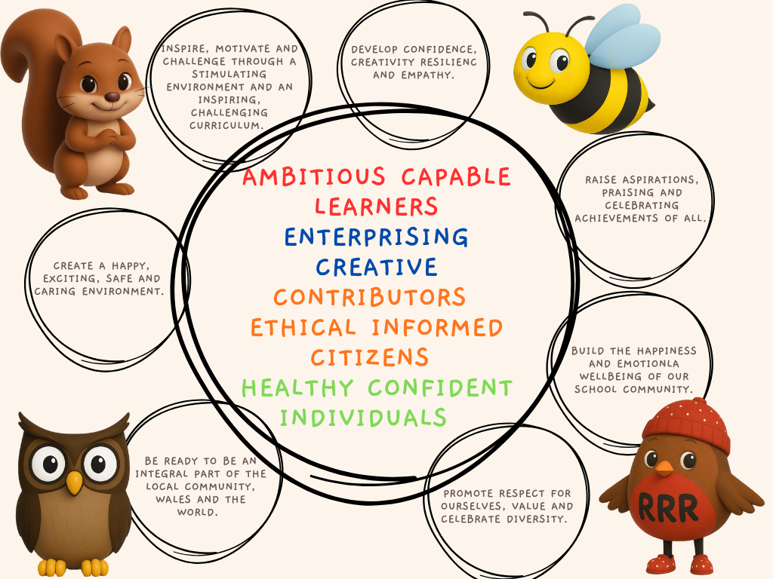

AIMS

Our aims for teaching and learning are that we will provide a framework that:

- Will help the school dream, believe, achieve, together
- Will keep our children happy, healthy and safe.
- Will offer our children the knowledge, skills and experiences to enable them to become; ambitious capable learners, enterprising creative contributors, ethical informed citizens and healthy, confident individuals
- Will raise standards of achievement and attainment for all children in an inclusive, safe environment which supports their wellbeing.
- Will continue to encourage open discussion and debate about learning within our school.
- Will establish an agreed range of practices in respect of learning and teaching and will promote an understanding of a range of pedagogical approaches which underpin good teaching and learning.
- Will enable staff to identify aspects of practice which they wish to develop within the school and support their research.
- Will endeavour to constantly improve the quality of learning experiences offered within our school.
- Will ensure learning occurs in a social context. The role of adults and other pupils in supporting and extending that learning is crucial.
- Will promote and facilitate children making choices with their learning
- Will focus on and recognise achievement.
- Will provide an agreed focus for monitoring and evaluation of the curriculum.

We believe that the key characteristics for a high-quality teaching and learning environment at Knelston school should include:
The Indoor/ Outdoor Classroom

The learning environment of the classroom should:

- Be clean, tidy, well organised and supplied with the relevant learning resources for the pupils' needs.
- Be stimulating, interactive and promote learning, including learning through purposeful, challenging displays in all classes including: Celebration; Growth mindset; work stations Welsh patterns.
- Facilitate independent and co-operative work by pupils.
- Encourage pupils to make choices about their own learning, and how to facilitate it.
- Enable pupils to have access to areas which promote independent learning and enquiry.
- Enable pupils to take increasing responsibility for the organisation and care of the learning resources.
- Provide areas of learning outdoors which are safe, secure and stimulating.
- Enable pupils to have access to a variety of I.T resources.
- Provide pupils with opportunities to develop and consolidate a range of skills across the curriculum.
- Provide pupils with opportunities to access local, national and global aspects of their learning.
- Enable pupils to develop and apply the attitudes, values, skills, knowledge and understanding relating to well-being.

The Extended Learning Environment

The extended learning environment should provide opportunities for pupils to:

- Experience first-hand learning through targeted visits and visitors to school.
- Work with other members of the school's community and members of the community e.g. local artists; writers in residence; PCSO and Firefighter visits.
- Experience at least one residential visit during their time in school
- Experience challenge and have opportunities to extend individual talents and skills through attending extra-curricular activities offered by school staff e.g. Music, Sports Clubs etc.
- Participate in school and/or public performances.
- Participate in local sporting tournaments and cluster school events including transition activities.

Section 2

Children:
- Start from what they know
- Learn because they are self-motivated
- Ask questions about their learning
- Value their own and others ideas
- Learn from their mistakes
- Make choices about their learning
- Recognise achievement above attainment.
- Respond appropriately to effective marking to move on their learning.
- Reflect on their own and others learning
- Have high expectations
- Must be ready to learn e.g. having a growth mindset, having the correct equipment.
- Should be taught to develop self-help strategies.
- Should make choices for learning and have opportunities for decision making.
- Contribute to why, what and how they learn.
- Use a range of approaches to learning
- Enjoy working together and on their own

Teachers:
- Plan tasks, investigations and enquiries to allow children to apply and consolidate skills across the range of AoLEs and progression steps
- Value every pupil and recognise the individuality of each child.
- Maintain high expectations of each pupil and help all pupils to reach their full potential.
- Value the contributions made by individuals.
- Have a clear understanding of the skills, knowledge, concepts and attitudes which are the goals of the learning process.
- Maintain an appropriate pace
- Provide clear learning objectives and outcomes for pupils.
- Use effective feedback, marking and the monitoring processes
- Are responsible for their own Continuing Professional Development
- Are the lead learners, showing we all learn together
- Use a range of pedagogical approaches to help all learners achieve
- Lead, motivate, enthuse and encourage learners
- Challenge pupils through effective questioning
- Use regular planning and assessment to promote better learning
- Give children choices in their learning
- Reflect and look for ways to improve their own teaching and learning
- Track pupil progress in accordance with the school's assessment procedures
- Ensure that pupils are aware of their next steps for learning
- As much as possible verbal feedback and assessments are given at the point of learning for instant action. Comments aim to be positive and constructive with meaningful next steps to help pupils progress.

Section 3

Sessions at Knelston Primary School will include:
- The learning objective, skills to be developed, links to previous skills learned and success criteria will be shared and agreed with the pupils at the start of the lesson.
- The climate of growth mindset will be discussed/ referred to so that all learners are confident to ‘have a go’ and are reminded of where to get help.
- A stimulus, the main teaching focus and differentiated activities which enable the children to achieve the objective.
- Opportunities for mini plenaries during lessons where success criteria will be discussed. Verbal feedback will be integral to support the learning.
- An appropriate pace which must be maintained during the lesson and the effectiveness of the planned activities must be evaluated.
- Time for thinking and reflection, and for children to respond to marking comments using purple pen.
- Regular feedback to pupils with high quality marking and feedback in accordance with the schools marking policy to ensure understanding and consolidation of intended objectives, and development of skills.
- Opportunities to develop and apply the cross curricular skills and cross cutting themes.

Monitoring and evaluation of Teaching and Learning (Looking for Learning)
- Regular book shares in staff meetings
- Learning walks
- Assessment of the quality of the feedback
- Review of the learning environment at regular intervals, for example, display, classroom organisation, resources
- Regular monitoring of the use of resources and their effectiveness in the context of teaching and learning
- Tracking of pupils’ progress through formative and summative assessments
- Evaluation over time of the national data available – Baseline Assessments, National personalised assessments
- Observation of teaching and learning
- Listening to children discussing their learning and progress
- Discussions with staff
- Parental surveys
- Pupil surveys
- Trio working: staff planning and supporting each other
- Structured opportunities for staff discussion about teaching and learning
- Staff planning together at outset of each topic
- Setting realistic but challenging targets for improvement
- Observation of behaviour and attitude

Section 4

Parental Support

At Knelston Primary School we encourage parents and carers to play an active role in their child's education through:

- Talking and listening to their child.
- Regular attendance
- Attending parental review meetings.
- Listening to their child read.
- Supporting Home/School tasks.
- Supporting school topics.
- Keeping up to date with school information through the school’s web site, twitter feed and reading weekly newsletter.
- Communicating any issues/concerns relating to their child to the school.
- Supporting social and fund raising events.

Governing Body Support

The role of the governing body in Knelston Primary School, with regards to learning and teaching is strategically planned for. The aims are:
- To be able to effectively measure and continuously improve pupil progress both in terms of achievement and attainment.
- To ensure that as a Governing Body we have high expectations and are continually improving provision particularly in terms of high quality learning and teaching.
- To place the development of the core purposes, Literacy, Numeracy, Pupil Wellbeing and the reduction of the impact of poverty at the forefront of our work.
- To ensure that the school provides excellent learning and teaching opportunities to enable every child to maximize their potential.
- To ensure that our school provides a highly nurturing and caring environment to encourage pupils and staff to grasp new opportunities and tackle new challenges.

This policy statement is the outcome of whole school meetings which aimed to review the principles identified for learning and teaching at Knelston Primary School.

As staff we:

- Reviewed our pedagogical approaches.
- Reviewed classroom organisation and identified the range of existing practice within our school.
- Reviewed and reorganised our resources for teaching and learning, and how they were being used to support learning.

Last review date: October 2025



Head teacher Chair of governors

